Power BI Assignment 2 – DAX & Data Visualization
Calculated Column
- Create a Calculated Column for 'Category Type': Add a calculated column in the
Order Details table that combines the 'Category' and 'Sub-Category' columns into a single 'Category Type' column
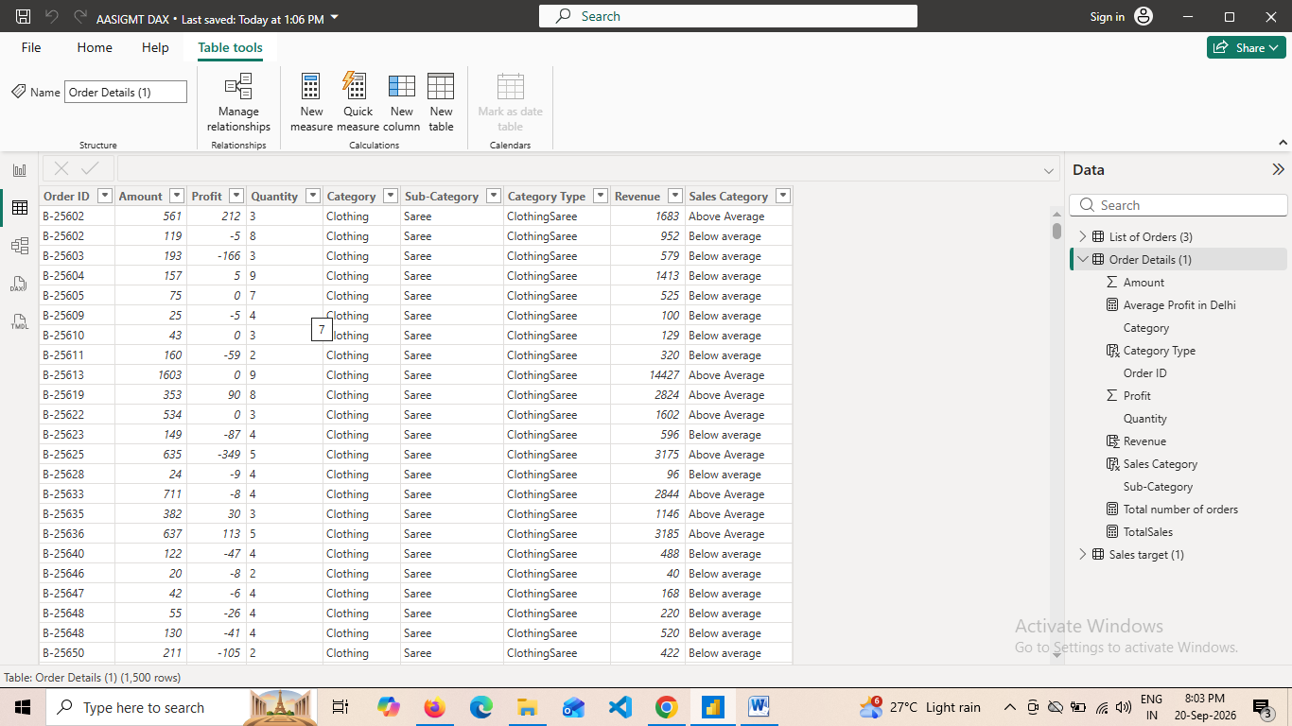

- Calculate Revenue per Order in Order Details Table: Create a calculated column in the Order Details table to compute the revenue (Amount * Quantity) per order
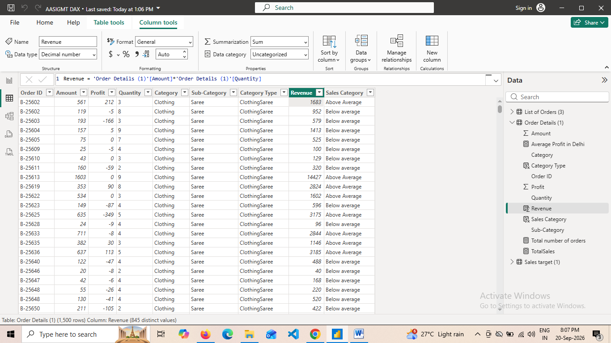

- Create a Calculated Column to Categorize Sales: Add a calculated column named
‘Sales Category’ in the Order Details table that categorizes each order as 'Above
Average' or 'Below Average' based on the Amount value.
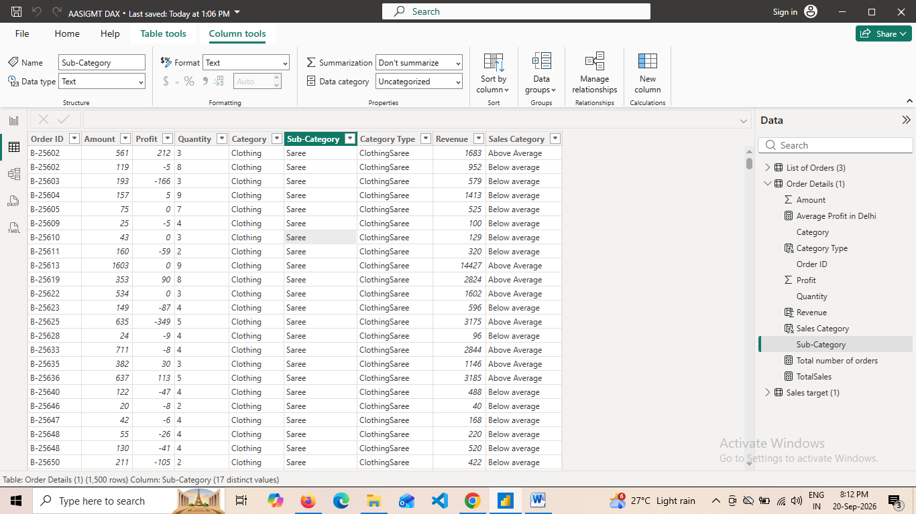
Calculated Measures:
- Calculate Order Count: Define a measure to count the total number of orders in the
Order Details table.
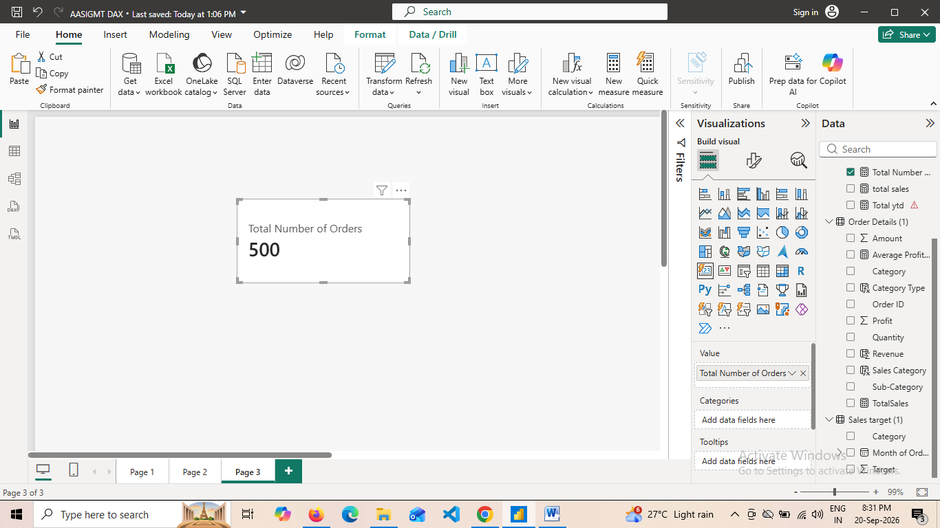

- Calculate Average Profit in Delhi: Create a measure to calculate the average profit for
orders placed in Delhi.
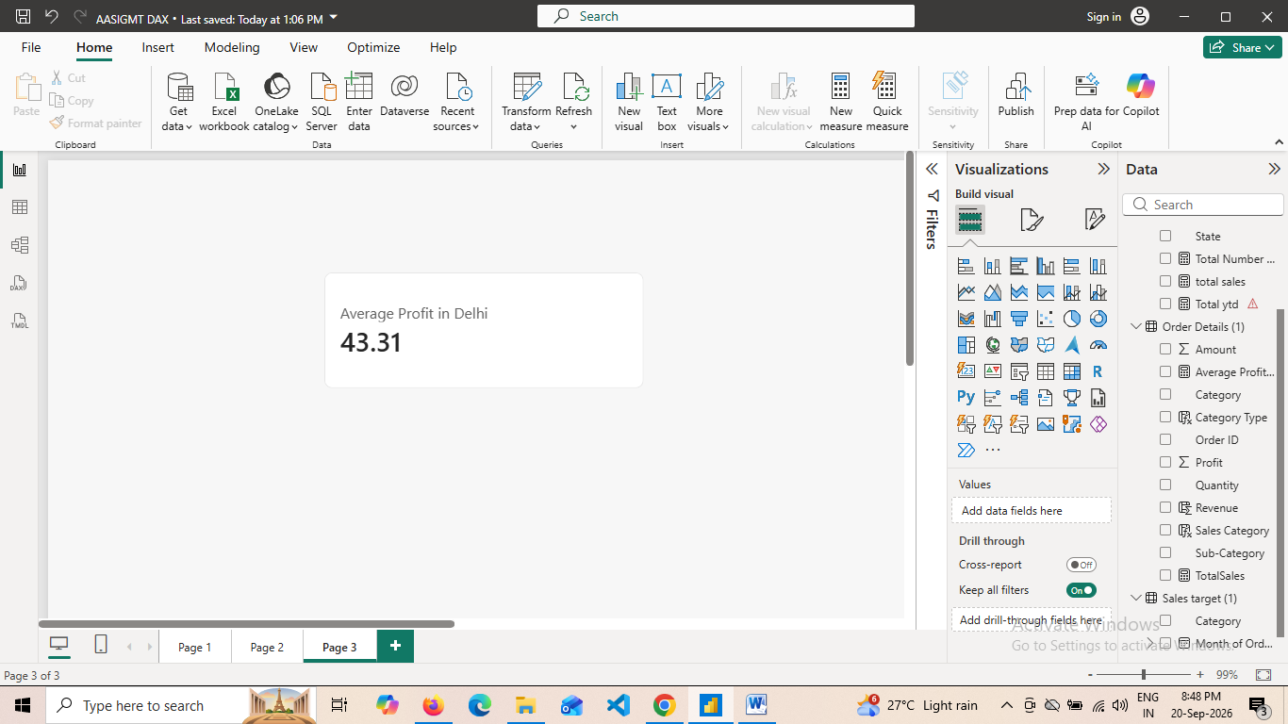
- Calculate Year-to-Date (YTD) Sales: Define a measure to calculate the total sales
amount accumulated from the earliest order date up to each order date
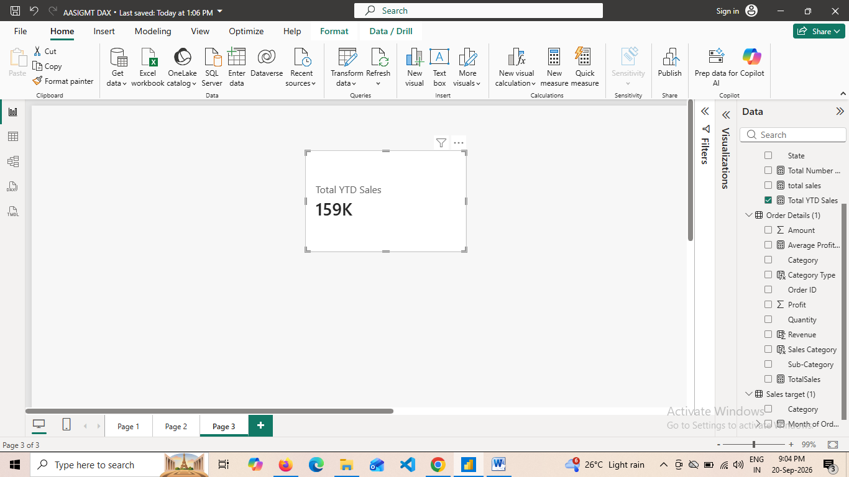

Data Visualization:

- Sales Target Achievement by Category: Compare actual sales with sales targets by
category using a clustered column chart
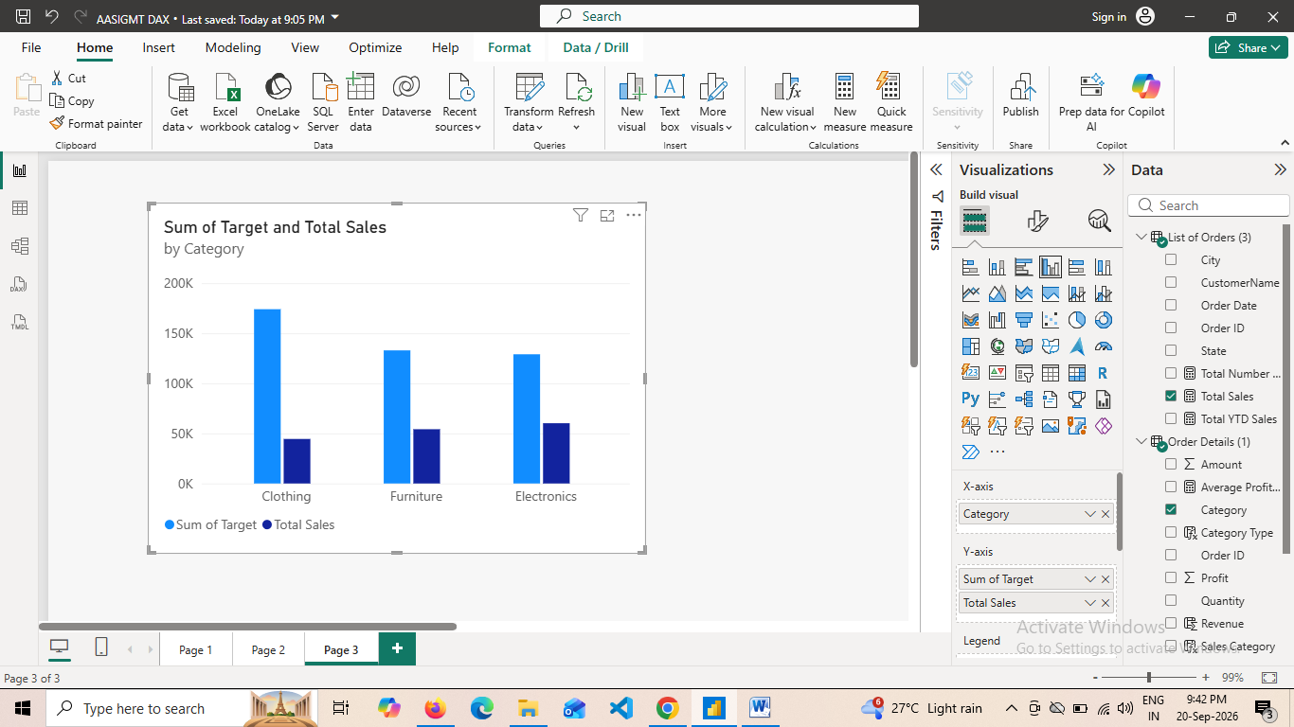
- Max Profit Margin by Sub-Category: Analyze the maximum profit margin for eachsub-category of products using a donut char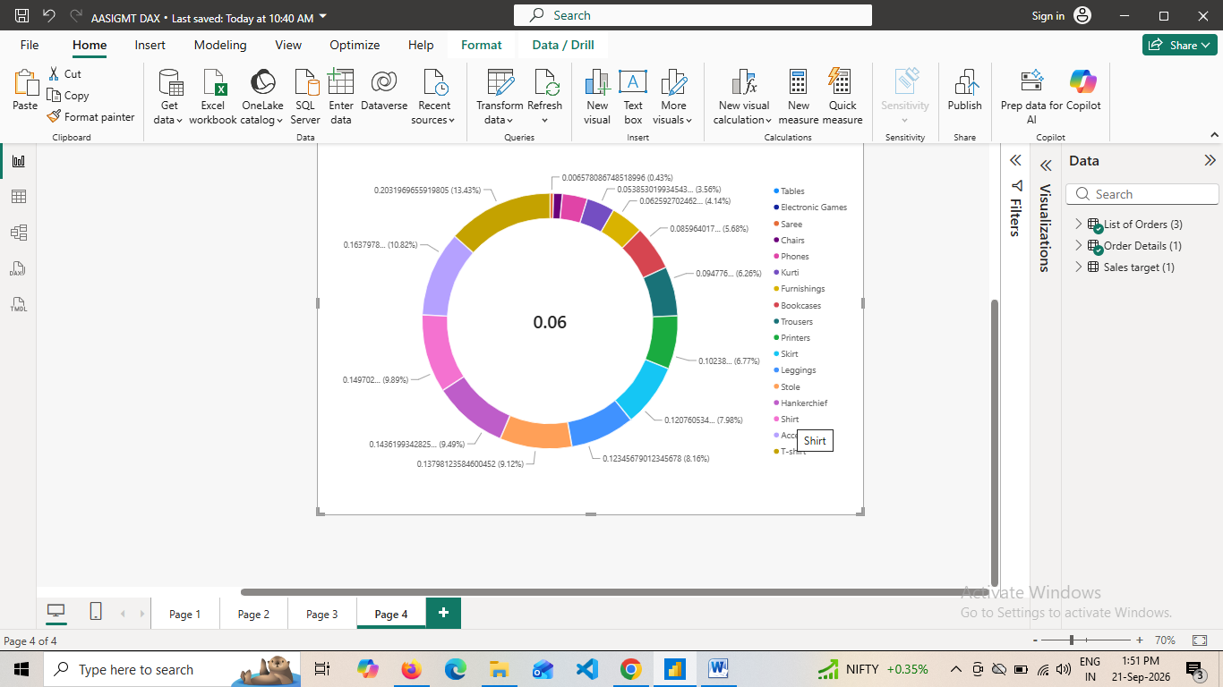

- Monthly Sales Trend: Show the trend of monthly sales over time using a line chart.

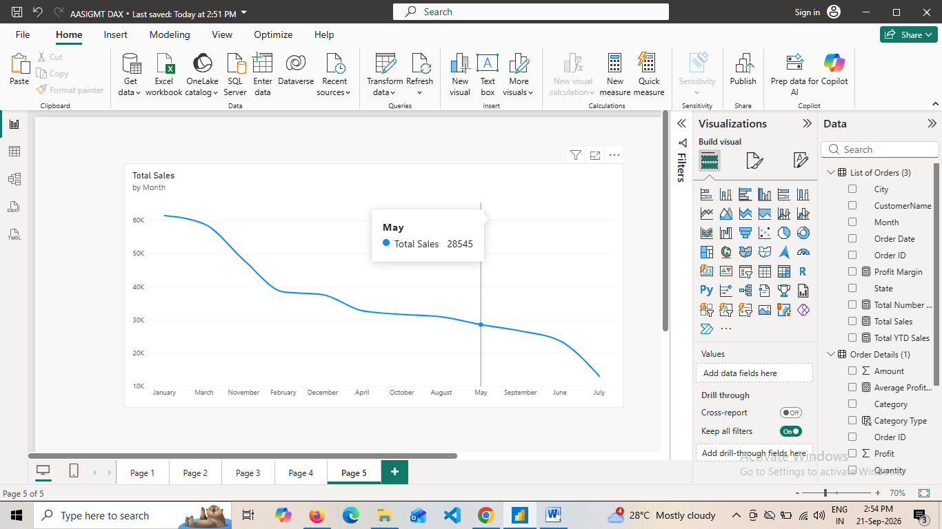

- Comparison of Profit and Quantity by Sub-Category: Compare the relationship between
profit and quantity sold for different sub-categories using a scatter chart

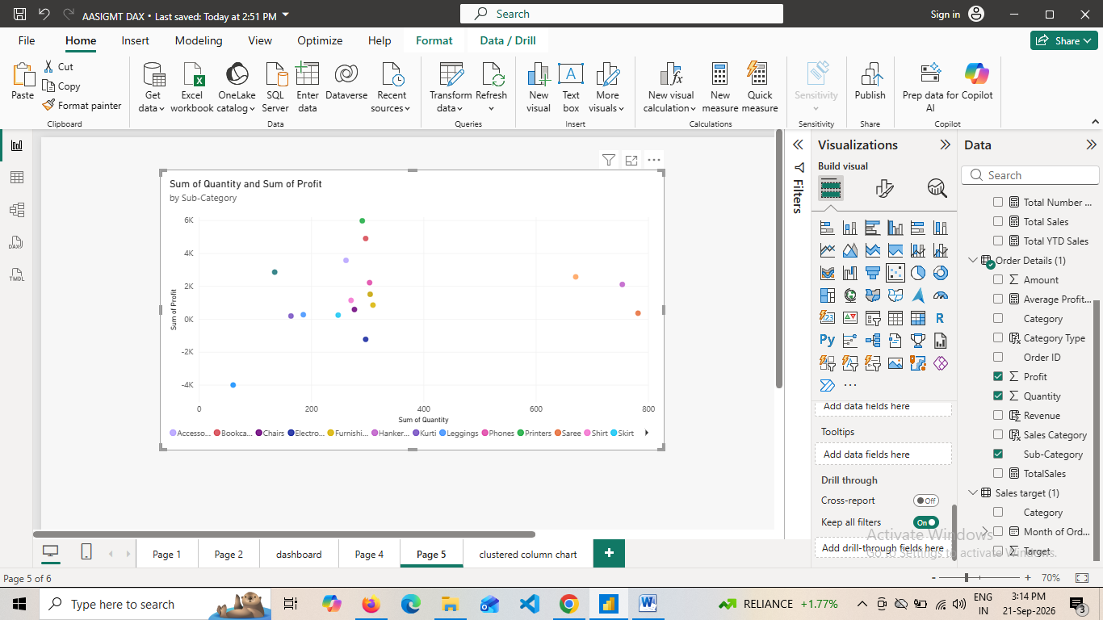
- Comparison of Total Sales Amount and Target: Create cards to succinctly display the total
sales amount alongside the sales target for quick comparison and analysis. Also, create a
multi-row card to display the minimum target for each segment.
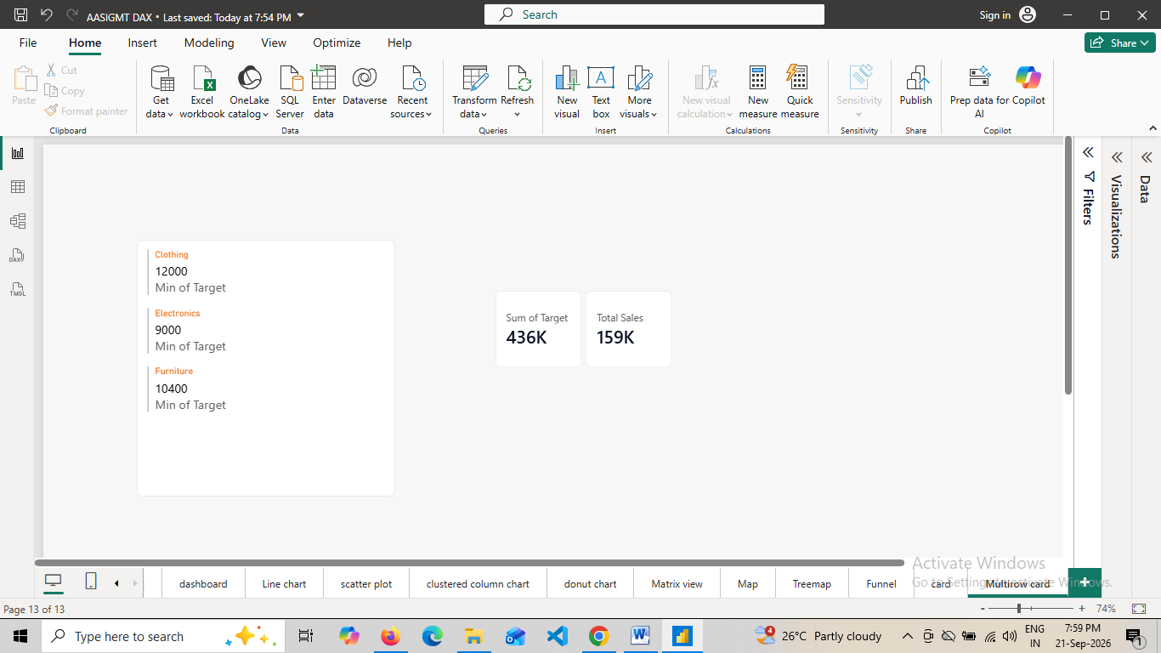

- Sales Performance Matrix: Build a matrix view to analyze how actual sales compare to
sales targets across different categories and month
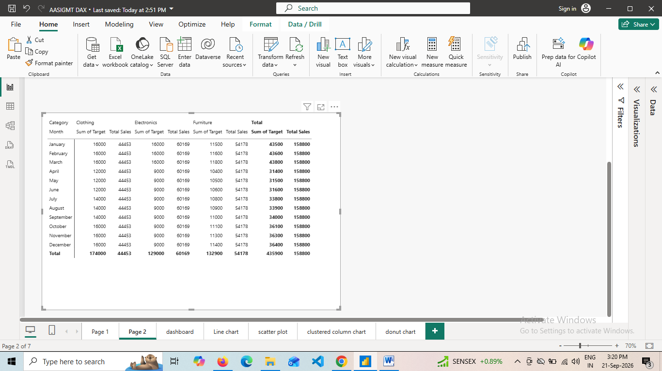
- Geographic Sales Analysis: Visualize total sales on a map by city to identify regional sales
Patterns
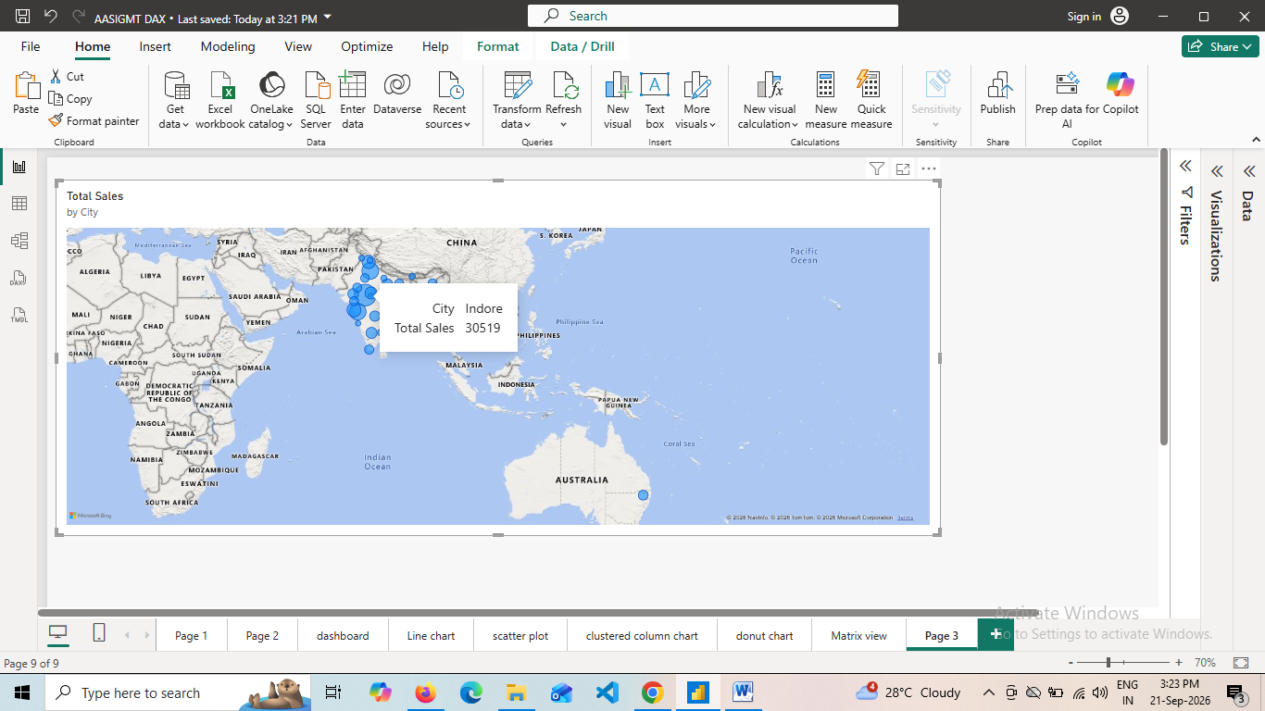

- Sales Distribution by Sub-Category: Represent the sales distribution across different
sub-categories using a treemap.
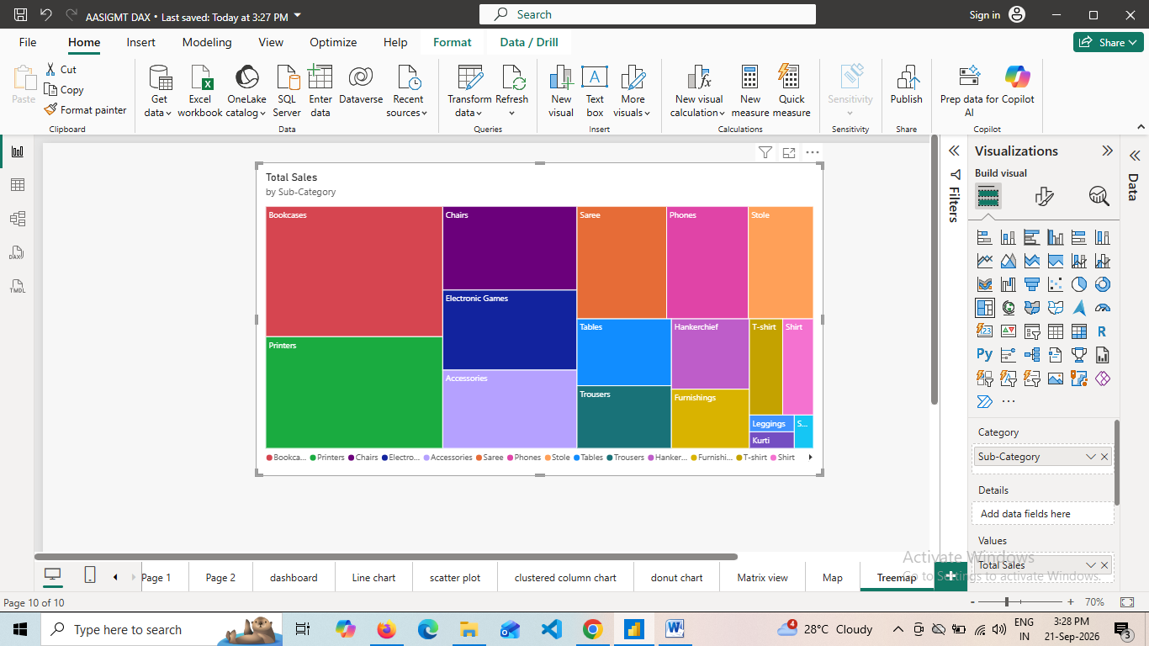
- Order Count Analysis by State: Create a funnel chart to visualize the distribution of order
counts across different states.
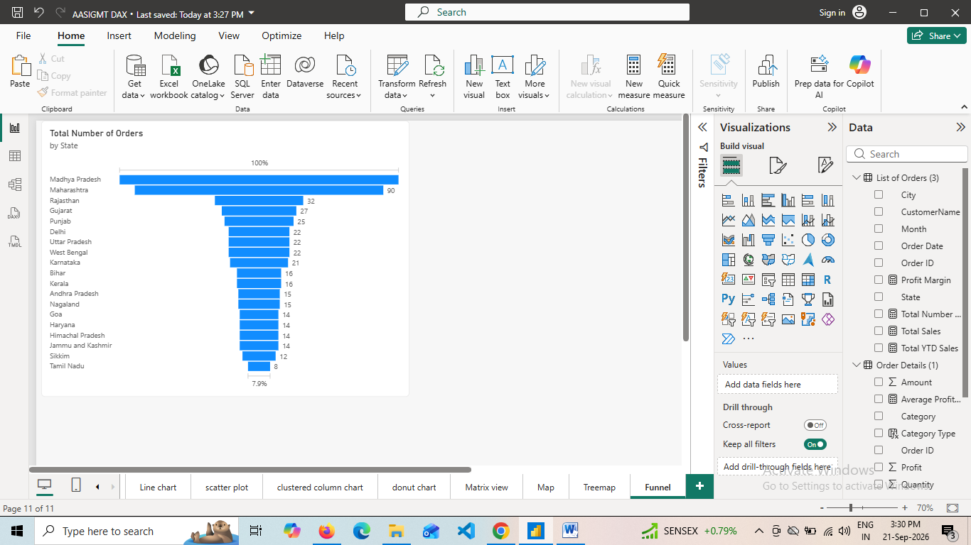

DASHBOARD
